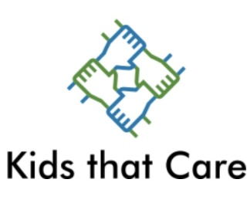
Dear Recipient:
Thanks for being interested in Kids that Care Marshalltown. We want to get to know what you care about, and what your dreams are for making the world a better place. Please fill out this paper and bring it with you to your first meeting. Thanks!
- If you had a million dollars to give away to charity, who would you give it to and why?

- What things do you see in your school or community that make you sad?

- What things do you see that give you hope?

- What has been one of your most fulfilling service projects or volunteer opportunities?

- What’s one project you’d like to see Kids that Care do?

- What is your favorite kind of pizza ?

641-691-2878
www.musicandamission.com

